REIKI I and II in JAPAN
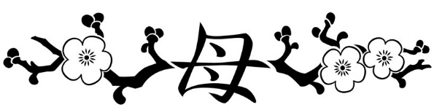

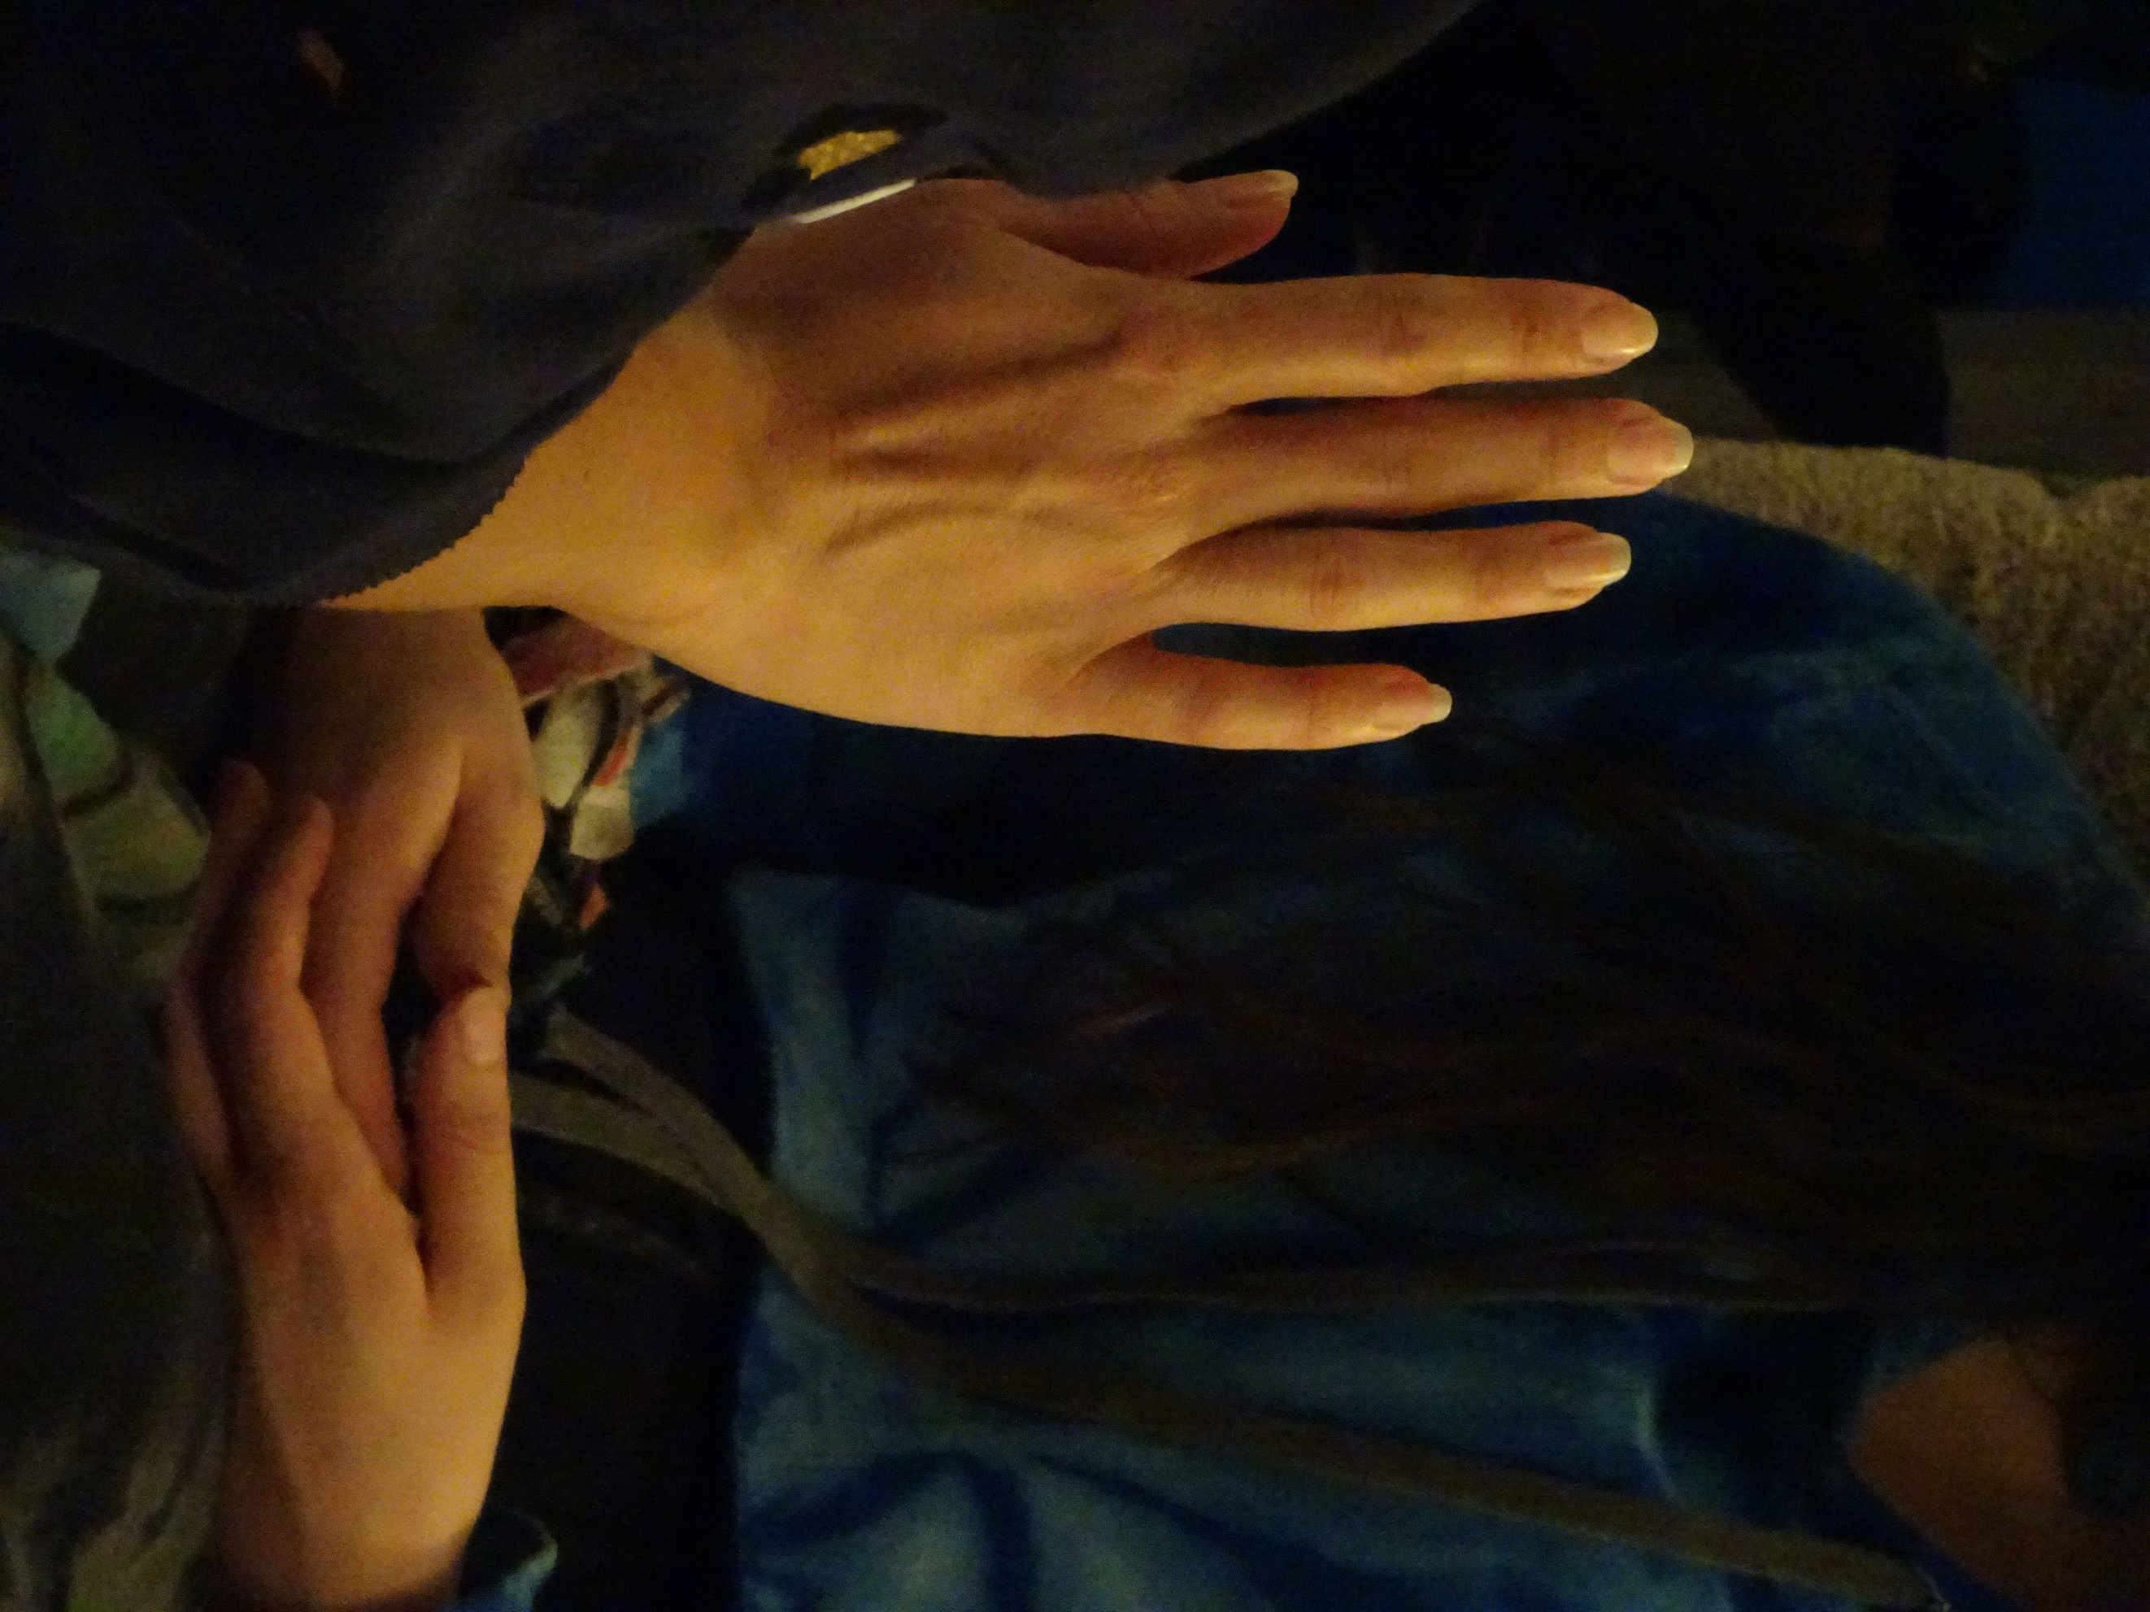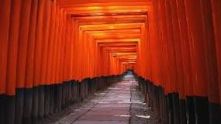
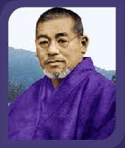
We are offering the unique opportunity, to take your Reiki I and II training in Japan, the homeland of founder Dr.Usui.
The course will lead to a Reiki practitioner certification. enabling you to work professionally as a paid Reiki therapist.
The classes will take place in Kyoto, a city famous for its temples, shrines, zen gardens and imperial palaces. We will be staying in a traditional ryokan or Japanese inn.
In Kyoto, there will be the opportunity for sight-seeing and cultural exchange. The highlight of our visit will be a day-trip to Mount Kurama, the birthplace of Reiki where Dr. Usui meditated for 21 days and received the Reiki healing energy. We will hike up to the top for a meditation, and on the way back down enjoy an outside bath at the local hot spring ‘onsen’.
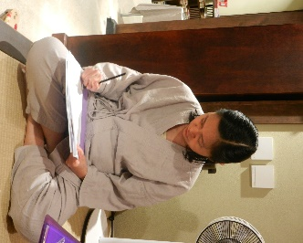
We will visit Shunkoin Temple where we will join in a Zen meditation. There is an opportunity to attend a calligraphy class and gain an insight into the world of a Geisha walking through Gion.
The training for Reiki I and Reiki II will be spread throughout the week.
We are running this course alongside the Reiki Masters, so in the evening you will have the opportunity to socialise with a number of international Reiki practitioners and enthusiasts. This will be an unforgettable physical and spiritual journey for anybody passionate about learning Reiki!
------------------------------------------------------------------

Date: 31st October to 7th November 2019

Venue: Kyoto, Japan

Fee: £1425.00 for B&B accommodation, all transport during the course, activities, excursion to mount Kurama, onsen bath, all entry fees and the service of a Japanese speaking tour guide.
Early bird offer: £1375.00 until 1st May

Reiki I & II course fee: add £400.00.

Excluded: Flights, insurance, meals, other than breakfast.

Included

- Reiki I and II courses including all tuition, manuals, course DVD and certification

- Seven nights’ B & B accommodation in a shared double room in a traditional Japanese Ryokan, with tatami-matted rooms, futon beds, Japanese style bath and breakfast. Visitors may wear yukata.
We have a couple of single rooms available at an additional fee.

- Free bus and train passes all week to explore Kyoto and surrounding

- Meditation and talk on mindfulness followed by tour of temple and tea/sweets at a Zen Temple

- Visits to Kinkakuji (Golden Temple), and Ryoanji (Famous Zen garden), Fushimi Inari shrine (1000 torii shrine made famous in Memoirs of a Geisha) and Gion (Historical Geisha district)

- Day trip to Kurama which includes hike up mountain, meditation, a meal in Kurama, and an onsen visit to cool off.

- All entry fees when sightseeing together.

- Calligraphy class. Daily onsen entry.
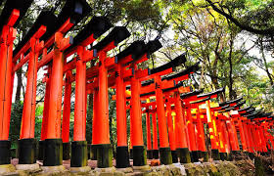
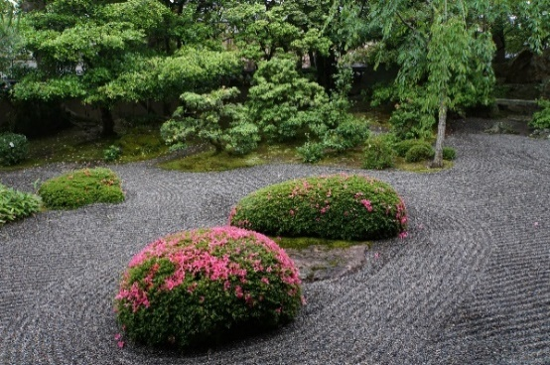
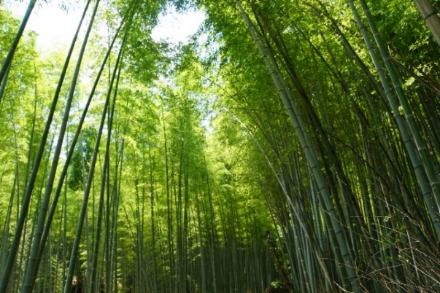
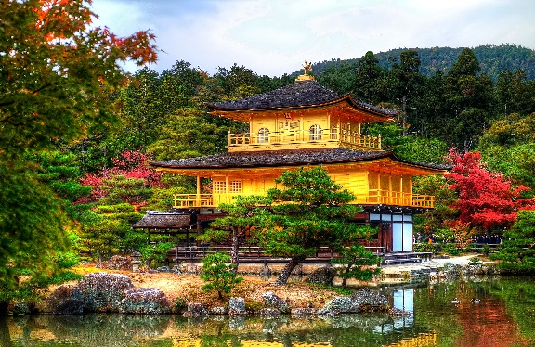

Your Reiki Master Teacher
Jacqueline Raison
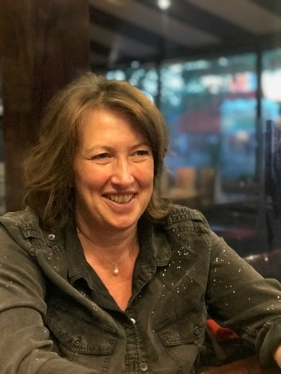
Jacqueline has been a keen student and practitioner of complimentary therapies for over 20 years. After initially practising Homeopathy, Herbalism and working with the Silva method, she discovered Reiki in 2014 and became fascinated by this method of healing.
She went to Kyoto, Japan with the award-winning Reiki School in 2018, completing her Master/Teacher certificate in Dr. Usui’s homeland.
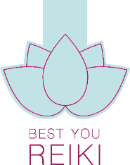
As well as the Usui Reiki system Jacqueline has learned Karuna Reiki, dowsing, Animal Reiki and has an in-depths knowledge of the Chakra system.
She has a thriving Reiki practice in the beautiful S. Oxfordshire countryside and is teaching all levels of Reiki.
Alongside her healing work Jacqueline works in the corporate world as a legal director, coaching and mentoring particularly on leadership, communication skills and emotional intelligence.
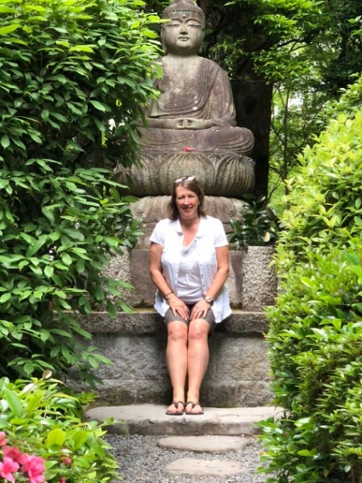
She has first-hand experience of trying to juggle a busy office-based role with bringing up children and a constant yearning for personal/spiritual growth.
Jacqueline has visited Japan 4 times in as many years and is now learning the Japanese language and Kanjii.
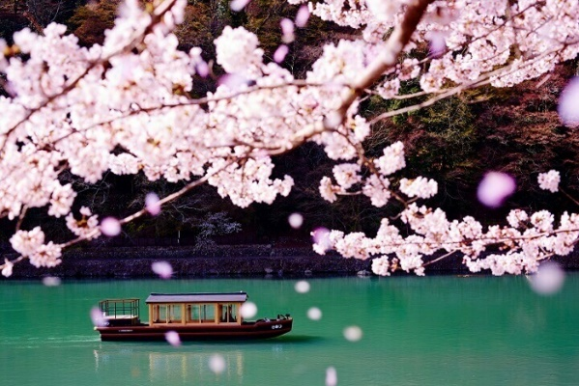

I am very much looking forward to introducing you to the wonderful world of Reiki in Dr.Usuis’ hometown and make the pilgrimage to Mount Kurama with you .

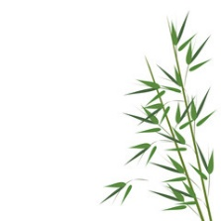
BOOKING FORM

Personal details
Title | Mr / Mrs / Ms / Miss / Other please specify:
First name |  | Surname
Date of birth |  | Gender |  | Male | Female
Address
Town |  | Postcode
Phone (daytime) |  | Mobile
Email
Passport No
Passport issue | Passport expiry date
Special requirements (diet, access etc)
Next of kin: Name |  | Tel.No
Relationship

Payment details
|__| I am transferring the course fee into the account of Tina Reibl, Halifax 11-05-08,
Account 00186221
IBAN: GB43HLFX11050800186221
BIC: HLFXGB21O42

|__| I enclose a cheque made payable to ‘Tina Reibl’

Please send this form and cheque(s) to:
Tina Reibl, 4 Lock Mead, Maidenhead SL6 8HF, UK
I transfer the £200.00 deposit via Paypal :
paypal.me/TheReikiSchool/200

Please note that Paypal payments can only be made for the £200.00 deposit, the remainder is payable by bank transfer or cheque, please.

