REIKI MASTERS IN JAPAN

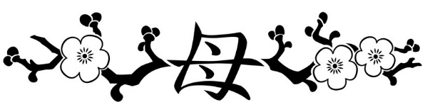

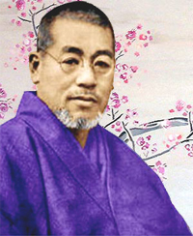 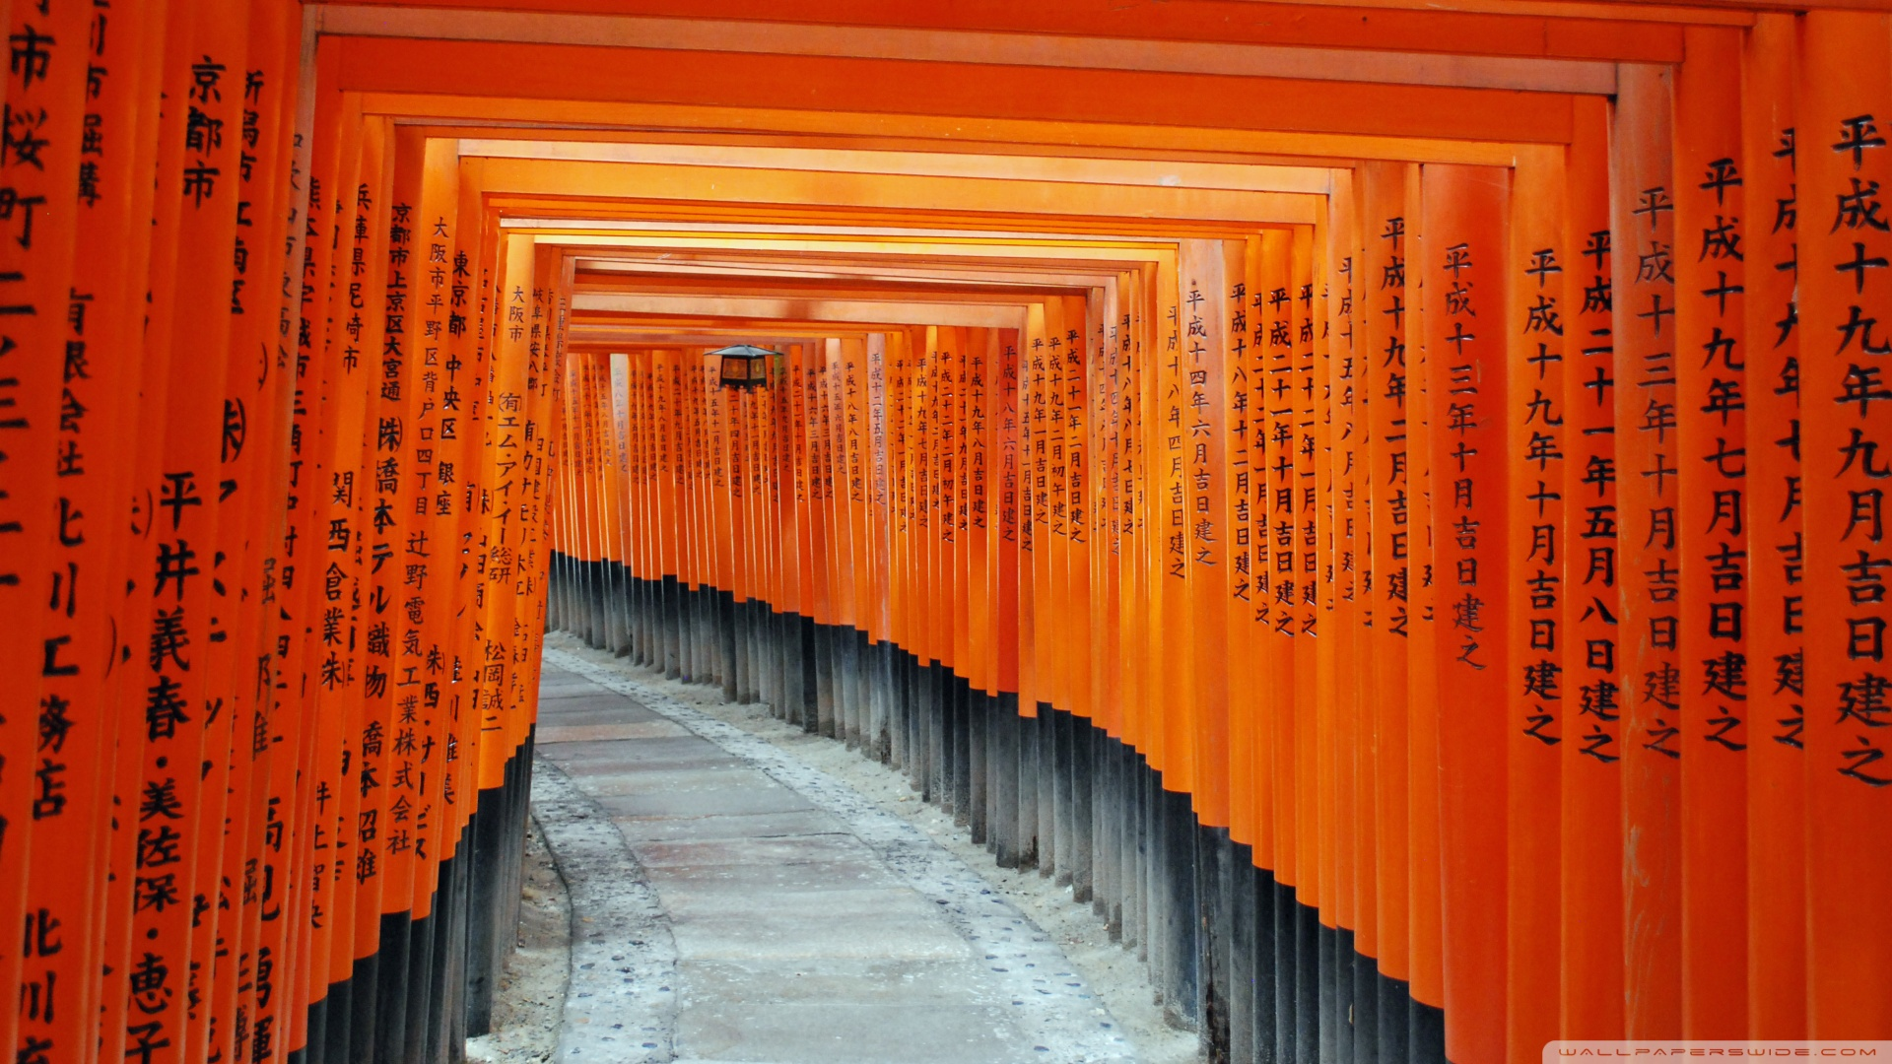 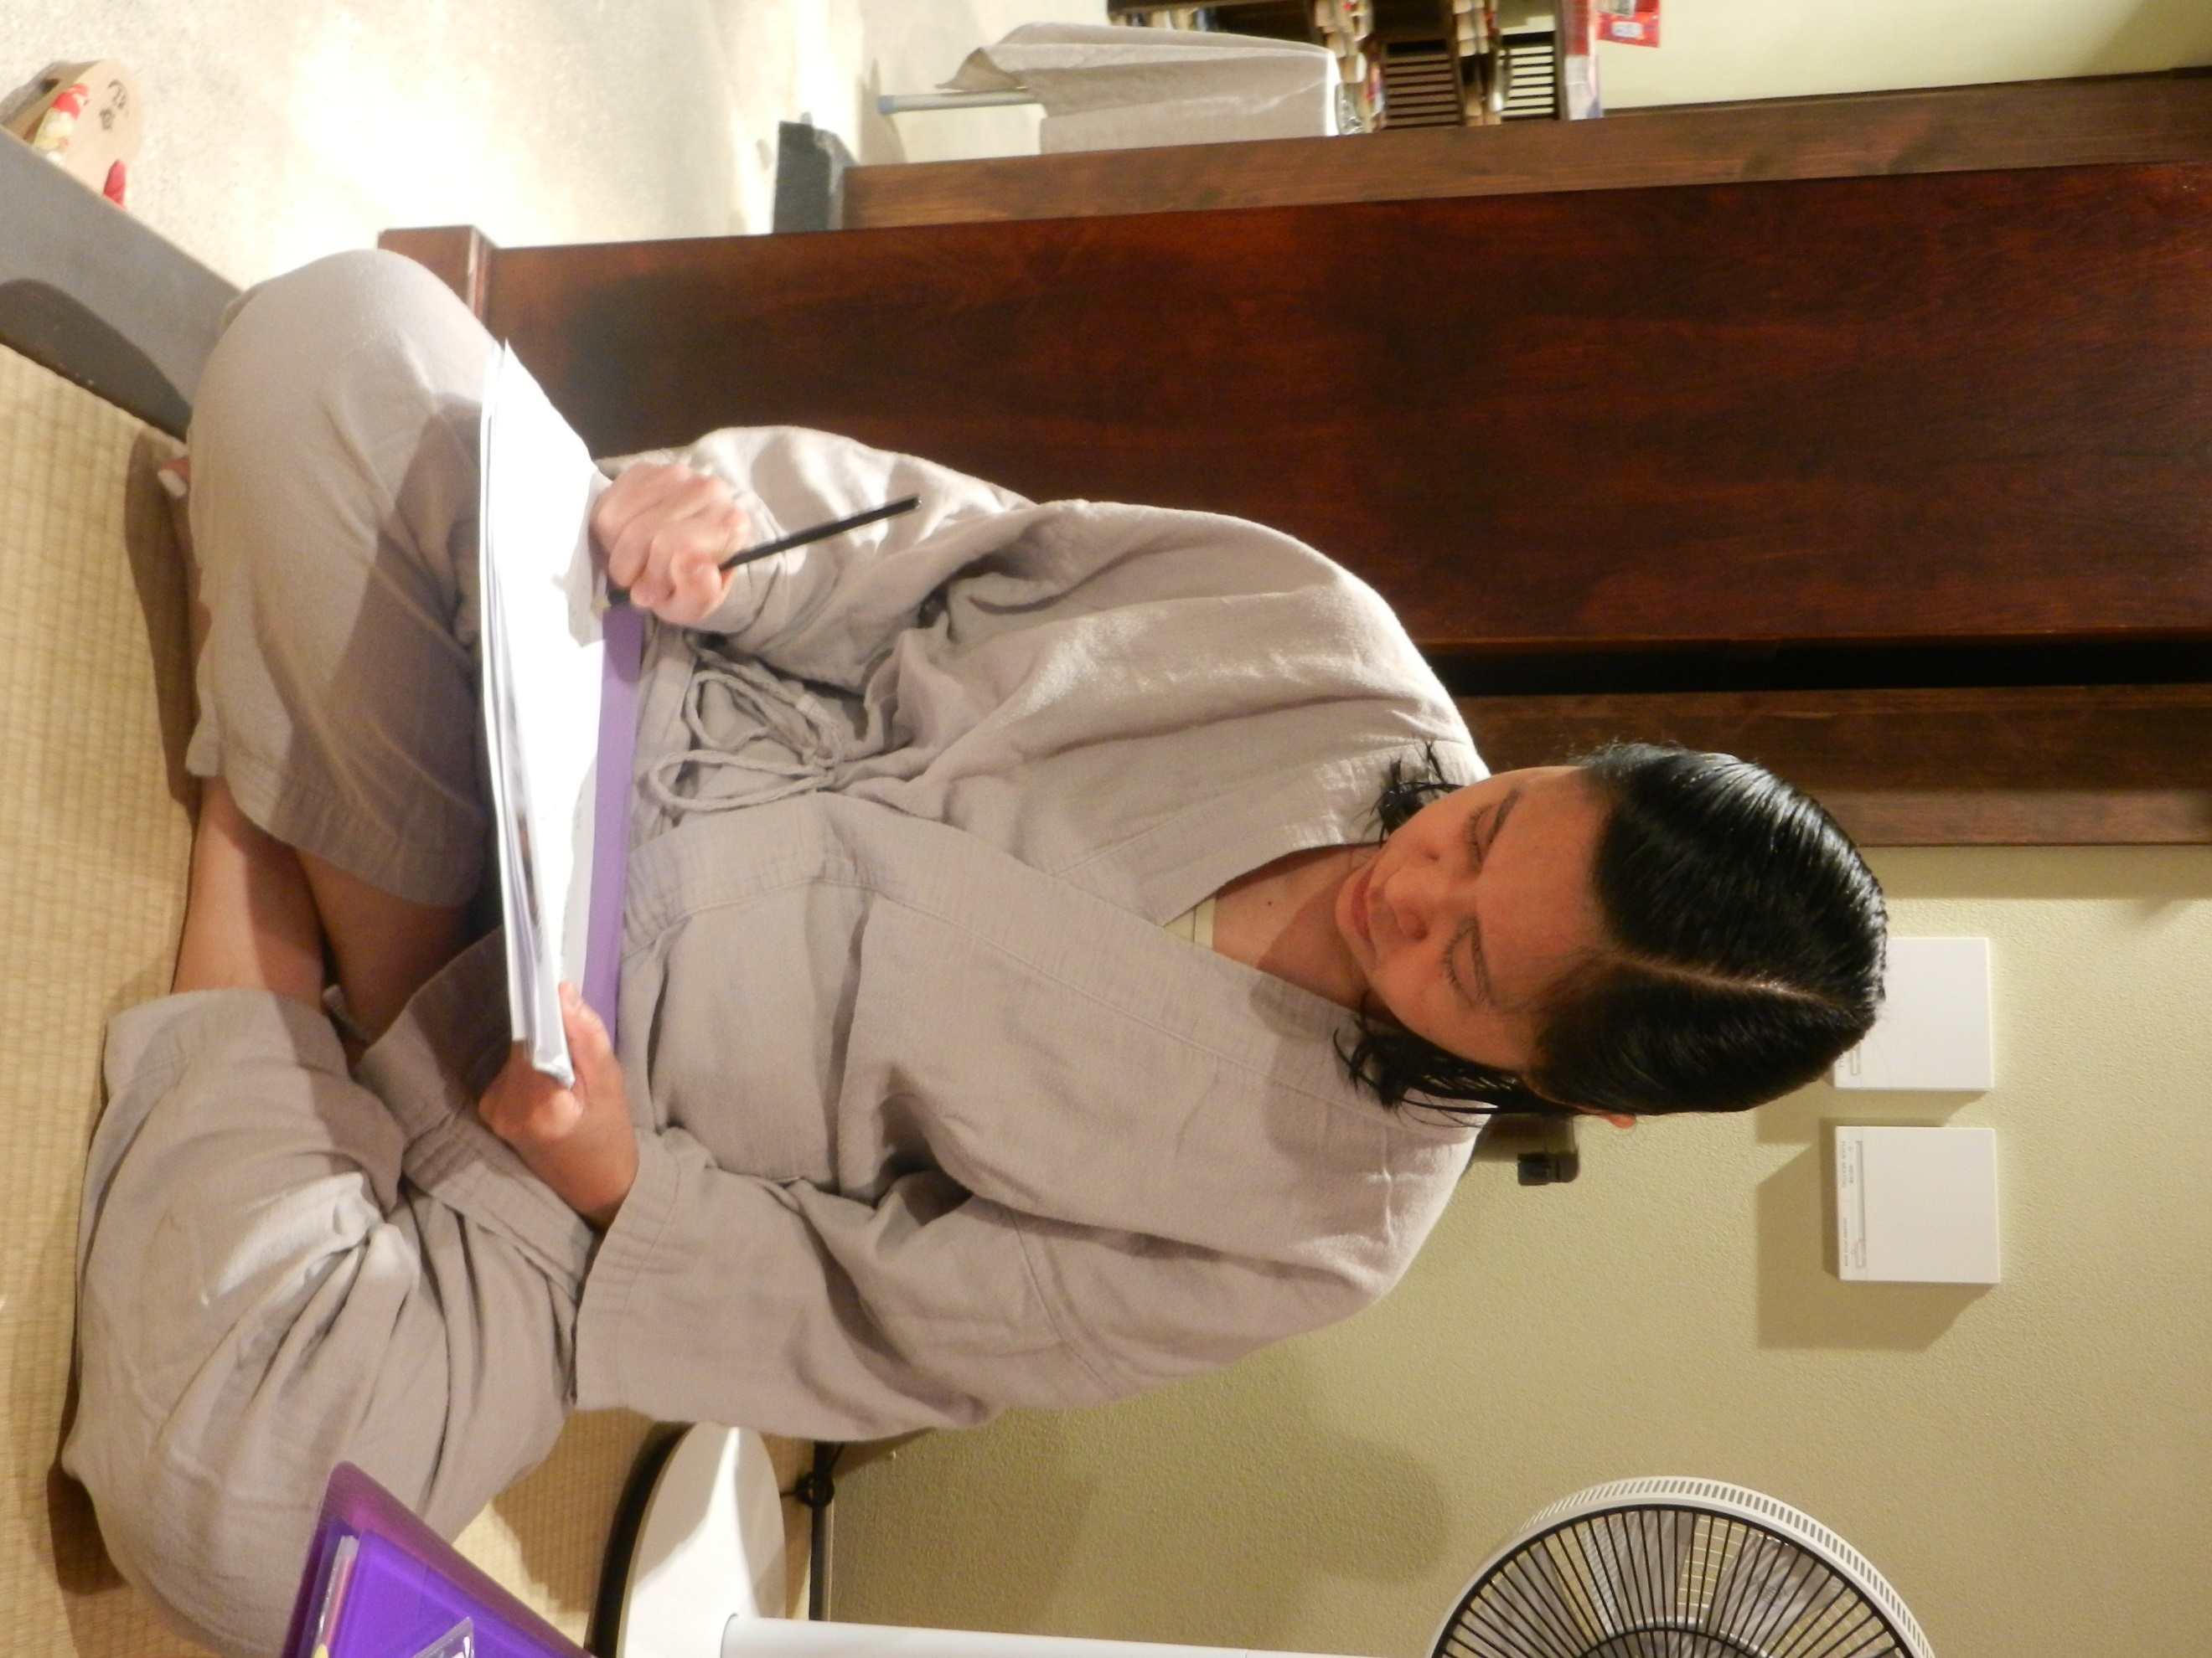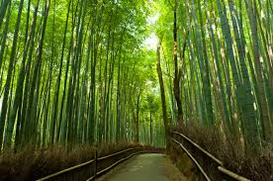

We are offering a unique opportunity to take your Reiki Master training in Dr Usui’s homeland, Japan, this Autumn, from 31st October to 7th November 2019**.**

The course will take place in Kyoto, the traditional heart of historic sights. We will be staying in a traditional ryokan or Japanese inn.

In Kyoto, there will be the opportunity for sight-seeing and cultural exchange. The highlight of our visit will be a day-trip to Mount Kurama, the birthplace of Reiki where Dr. Usui meditated for 21 days and received the Reiki healing energy. Kurama has many different frequencies and patterns of high vibration. We will hike up to the top for a meditation, and on the way back down enjoy an outside bath at the local hot spring ‘onsen’.

The full two-day Reiki Master Teacher course will be spread out throughout the week. We will visit Shunkoin Temple where we will join in a Zen meditation. There is an opportunity to attend a calligraphy or tea ceremony class and gain an insight into the world of a Geisha walking through Gion.

This will be an unforgettable physical and spiritual journey for anybody passionate about Reiki!

--------------------------------------------------------------

Date: 31st/10/201 to 7th/11/2019

Venue: Kyoto, Japan

Fee: £1425 for B&B accommodation, all internal transport,activities,   
 excursion to mount Kurama, onsen bath, all entry fees and the   
 service of a Japanese speaking tour guide.  
 EARLY BIRD: £1375.00 until 1st May 2019

Master/Teacher course fee: add £500.00.

Excluded: Flights, meals, other than breakfast.

Included

* Reiki Master/Teacher course including all tuition and certification
* Seven nights’ B & B accommodation in a shared double room in a traditional Japanese Ryokan, with tatami-matted rooms, futon beds, Japanese style bath and breakfast. Visitors may wear yukata.
* Free bus and train passes all week to explore Kyoto and surrounding
* Meditation and talk on mindfulness followed by tour of temple and tea/sweets at a Zen Temple
* Visits to Kinkakuji (Golden Temple), and Ryoanji (Famous Zen garden), Fushimi Inari shrine (1000 torii shrine made famous in Memoirs of a Geisha) and Gion (Historical Geisha district)
* Day trip to Kurama which includes hike up mountain, meditation, a meal in Kurama, and an onsen visit to cool off.
* All entry fees when sightseeing together.
* Calligraphy class and evening cultural show.

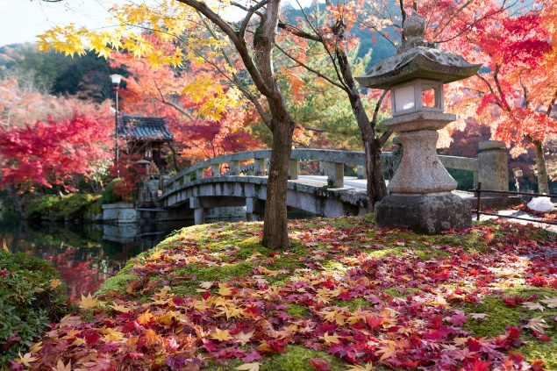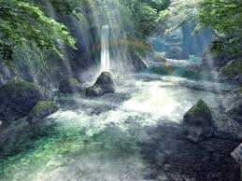



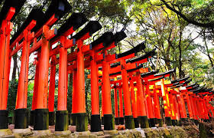

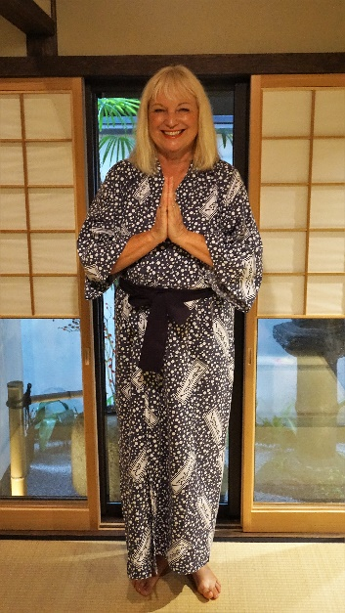TINA REIBL

YOUR REIKI MASTER TEACHER

Tina has been a passionate and commited Reiki Master for over 20 years. She has taught hundreds of Reiki students over her time as a Master and many of her students are now successfully working as healers and teachers. Tina’s Reiki School has just been awared *'Reiki Training School of the Year 2019 - South East England'.*

Tina is a consultant hypnotherapist and Master of NLP. She brings her considerable understanding of human nature to her work as a holistic healer.

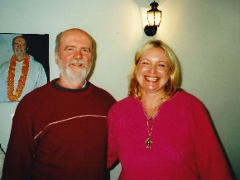Tina is only 6th down in lineage from Sensei Usui himself. Her Karuna® Reiki Master is William Rand.

In 2001 Tina visited the World Reiki Day in India and had the opportunity to study with Walter Luebeck, Frank Arjava Petter and William Rand. She was invited to assist William Rand at Reiki I and II.

Tina usually offers her Masters course in beautiful sacred Avebury where each year many crop-circles appear. This power spot amplifies the Reiki energy and makes the Masters training really special.

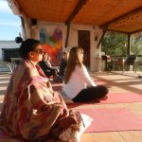In the last few years Tina has started to work internationally, offering healing and creative retreats around the globe. Teaming up with gifted yoga and art teachers she has run several workshops in India, Turkey and Spain.

This forthcoming Reiki Masters course in Japan was the fulfilment of a life-long dream for Tina. Only planned as a one-off event it is now the fourth time Tina will run the Masters in Kyoto due to high demand.

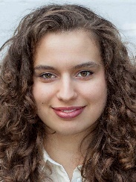Her daughter Joy, a Reiki practitioner also, has studied Japanese at Oxford University and lived in the country. She will be expertly guiding the group and will be available for help and advice in all things Japanese – from food to customs.

We are both tremendously looking forward to walk in Dr.Usuis’ footsteps and make the pilgrimage to Mount Kurama with you .

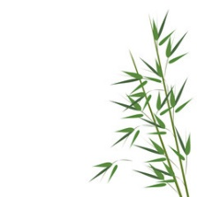

BOOKING FORM

Personal details

|  |  |  |  |  |  |
| --- | --- | --- | --- | --- | --- |
| Title | Mr / Mrs / Ms / Miss / Other please specify: | | | | |
| First name |  | Surname | |  | |
| Date of birth |  | Gender | | Male | Female |
| Address |  | | | | |
| Town |  | Postcode | |  | |
| Phone (daytime) |  | Mobile | |  | |
| Email |  | | | | |
| Passport No |  | | | | |
| Passport issue | **Passport expiry date** | | | | |
| Special requirements *(diet, access etc)* | |  | | | |
| Next of kin: Name |  | **Tel.No** |  | | |
| Relationship |  |  | | | |

Payment details

|__| I **am transferring the course fee into the account of Tina Reibl, Halifax 11-05-08,   
Account 00186221  
IBAN: GB43HLFX11050800186221   
BIC: HLFXGB21O42**

|  |
| --- |
| |__| I enclose a cheque made payable to ‘Tina Reibl’ |

Please send this form and cheque(s) to:

Tina Reibl, 4 Lock Mead, Maidenhead SL6 8HF, UK

**I transfer the deposit via Paypal :   
 paypal.me/TheReikiSchool/200**

Please note that Paypal payments can only be made for the deposit, the remainder is payable by bank transfer or cheque, please.